**Project Title: Key Pad Number Guessing Game**

**Class: 2nd Semester Department: BS-Computer Science**

***Project Participants:***

1. **Ahmad Ahsan**
2. **Muhammad Umair**
3. **Muhammad Hamza Abid**

**Project Description:**

This number guessing game is quite simple. In this game the player thinks of any number between 1 and 99. Then he scans the eight groups of numbers given in the eight boxes in the table. Each group corresponds to a specific switch (indicated on the top of each group) on an 8-way DIP switch. The person scans the numbers in each box and slides the switch corresponding to a box to ‘on’ position if he finds his number in that box. After having scanned all the eight boxes and switching on the relevant DIP switches, he is required to press switch S9 and the number thought of by the person is displayed on the 7-segment displays. After this, all switches on the 8-way DIP switch need to be turned off to try display of another number in a similar fashion.

**Components:**

* **Capacitors**
* **Resistors**
* **Seven Segment Display**

**Project Principal:**

In this number guessing game circuit, NE555 a stable generates a clock for the circuit, which provides a oscillating wave to the output pin 3 of IC1. The time period of counter can be calculated by following formula:

**T = 0.7 (R1 + 2*R2)*C1.**

Assemble the circuit properly as shown in circuit diagram. Connect the pin 3 of both the IC1 and IC2 to supply, to on the display. If pin 3 is connected to ground we will not get display on 7 segment output. Also connect the pin 15 which is a reset pin to ground so that when counting reaches to 99 it will reset the counter to zero. Lastly, connect the pin 2 to ground if this pin is held high then counter will not advance. Now apply power supply. Zero will be displayed on both the 7 segment display. And counter starts counting by receiving pulse from IC3. As NE555 is wired in a stable mode it is generating continuous pulses which make the clock pin1 of IC1 high after every specific period of time. After receiving the clock pulse, 4026 IC counter advances and 1 will be displayed on common cathode of 7 segment displays. When second pulse is encountered it will again make the pin 1 of IC1 high and 2 will be displayed and similar phenomenon occurs till count reaches 9. When it reaches 9, one cycle is completed. As you can see from circuit diagram, pin 5 is a divide by 10 output pin means after every 10 input pin 5 goes high. This property can be utilized to connect more numbers of 4026. In short we can cascade many 4026 to increase the number of 7 segment display. That’s why we have connected the pin 5 of IC1 to pin 1 of IC2 to cascade another IC, after every 10th pulse it will go high to provide a clock pulse to IC2 to advance its counter, therefore we will receive a 1 on 7 segment common cathode display2. Unit place number are displayed on display1 and tens place numbers are displayed on display2. After completion of each cycle, tens place advances one. Similarly you can add N numbers of 4026 IC with 7 segment display. Cover the display and ask everyone who are playing to assume a number. Switch on S1 and when anybody says stop, switch off S1. See the number displayed on the screen, if same number is there which a player has assumed then he or she has won the game otherwise lost the game. In this you can also vary the speed of numbers which are displaying on 7 segment display by using a variable resistor in place of R2 in the range from 5K to 50K. 4026 IC is very sensitive to atmosphere you can also utilize this feature just remove the NE555 IC and add a wire at pin 1 of IC1. Touch this with your finger and you will see that counter has advanced and you can play. Try using it on other applications.

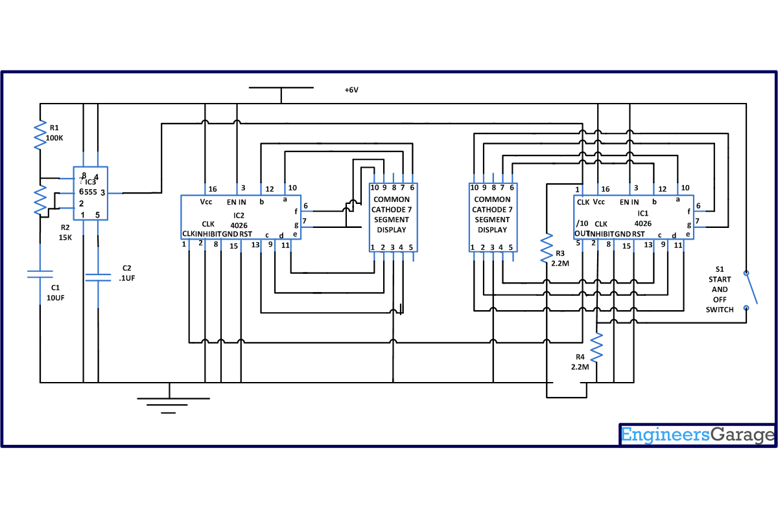

**Project Submission Date:**

**Instructor Signature: Date:**